Name: AMRITANSH ANAND Reg. No.: 20BCE1650 Date: 09/11/22

**IWP Digital Assignment - 2**

LINK TO ALL THE CODE:

<https://drive.google.com/drive/folders/1Frv9lLOkikjA2aSrFxq2bIhhhrZn7VBk?usp=share_link>

<?php

$conn = mysqli_connect("localhost", "root", "", "da2");

if($conn-> connect_error)

die("connection failed:".$conn->connect_error);

if(isset($_POST['usr'])){

$usr = $_POST['usr'];

$pas = $_POST['pas'];

$c=0;

$query = "SELECT usr,pas FROM det";

$result = mysqli_query($conn,$query);

while($row = mysqli_fetch_array($result)){

if(strcmp($row['usr'],$usr)==0 && $row['pas']==$pas && $usr[0]=='f'){

header("Location:http://localhost/IWP_DA2/faculty.html");

$c=1;

}

else if(strcmp($row['usr'],$usr)==0 && $row['pas']==$pas && $usr[0]=='s'){

header("Location:http://localhost/IWP_DA2/student1.php");

$c=1;

}

}

if($c==1)

echo "<I><B>Incorrect Credentials!! Try again..</B></I>";

}

$conn->close();

?>

<!DOCTYPE html>

<html lang="en">

<head>

<meta charset="UTF-8">

<meta http-equiv="X-UA-Compatible" content="IE=edge">

<meta name="viewport" content="width=device-width, initial-scale=1.0">

<title>LMS</title>

<style>

h1{

text-align: center;

}

input[type="text"],[type="password"],[type="submit"]{

margin: 10px;

padding: 10px;

border-radius: 10px;

}

input[type="submit"]{

background-color: rgb(17, 0, 255);

color: white;

}

input[type="submit"]:hover{

background-color: rgb(0, 0, 0);

}

div{

padding-top: 200px;

}

</style>

</head>

<body>

<div>

<h1>LOGIN</h1>

<form action="login.php" method="POST" align="center">

<input type="text" placeholder="Username" name="usr" id="usr" size="30"><br>

<input type="password" placeholder="Password" name="pas" id="pas" size="30"><br>

<input type="submit" value="Log in" size="30" style="width: 235px;">

</form>

</div>

</body>

</html>

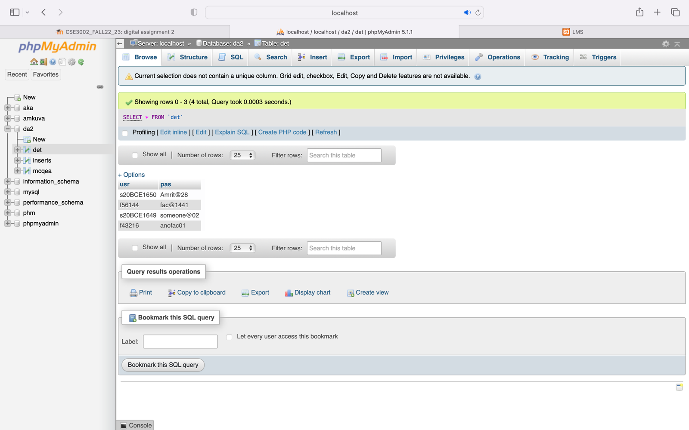

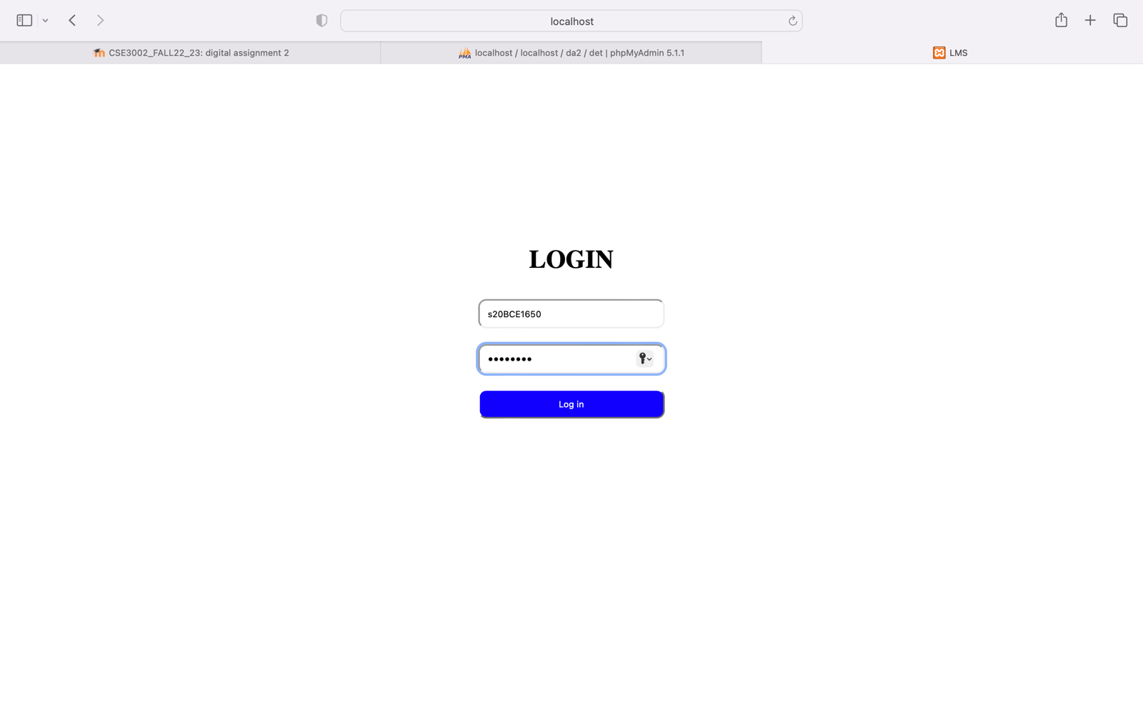

<?php

$con = mysqli_connect("localhost", "root", "", "da2");

if($con-> connect_error)

die("connection failed:".$con->connect_error);

if(isset($_POST['submit'])) {

if(!empty($_POST['ques1'])){

$insert = false;

foreach($_POST['ques1'] as $ques1){

$sql = "INSERT INTO `da2`.`mcqea` (`enteredans`, `date`) VALUES ('$ques1', current_timestamp());";

if($con->query($sql) == true){

$insert = true;

}

}

}

if(!empty($_POST['ques2'])){

$insert = false;

foreach($_POST['ques2'] as $ques2){

$sql = "INSERT INTO `da2`.`mcqea` (`enteredans`, `date`) VALUES ('$ques2', current_timestamp());";

if($con->query($sql) == true){

$insert = true;

}

}

}

if(!empty($_POST['ques3'])){

$insert = false;

foreach($_POST['ques3'] as $ques3){

$sql = "INSERT INTO `da2`.`mcqea` (`enteredans`, `date`) VALUES ('$ques3', current_timestamp());";

if($con->query($sql) == true){

$insert = true;

}

}

}

if(!empty($_POST['ques4'])){

$insert = false;

foreach($_POST['ques4'] as $ques4){

$sql = "INSERT INTO `da2`.`mcqea` (`enteredans`, `date`) VALUES ('$ques4', current_timestamp());";

if($con->query($sql) == true){

$insert = true;

}

}

}

if(!empty($_POST['ques5'])){

$insert = false;

foreach($_POST['ques5'] as $ques5){

$sql = "INSERT INTO `da2`.`mcqea` (`enteredans`, `date`) VALUES ('$ques5', current_timestamp());";

if($con->query($sql) == true){

$insert = true;

}

}

}

header("Location:http://localhost/IWP_DA2/student2.php");

}

$con->close();

?>

<!DOCTYPE html>

<html lang="en">

<head>

<meta charset="UTF-8">

<meta http-equiv="X-UA-Compatible" content="IE=edge">

<meta name="viewport" content="wvalueth=device-wvalueth, initial-scale=1.0">

<title>LMS/student1</title>

<style>

h1{

text-align: center;

padding-top: 20px;

}

h3{

padding-top: 40px;

}

input[type="submit"]{

margin: 10px;

padding: 10px;

border-radius: 10px;

background-color: rgb(17, 0, 255);

color: white;

margin-top: 40px;

}

input[type="submit"]:hover{

background-color: rgb(0, 0, 0);

}

</style>

</head>

<body>

<div>

<h1>MCQ (Page 1/4)</h1>

<form align="center" action="student1.php" method="POST">

<h3>Question 1</h3>

<input type="checkbox" value="OptA" name="ques1[]">

<label for="OptA">a) Option A</label>&nbsp;&nbsp;&nbsp;&nbsp;&nbsp;&nbsp;&nbsp;

<input type="checkbox" value="OptB" name="ques1[]">

<label for="OptB">b) Option B</label>&nbsp;&nbsp;&nbsp;&nbsp;&nbsp;&nbsp;&nbsp;

<input type="checkbox" value="OptC" name="ques1[]">

<label for="OptC">c) Option C</label>&nbsp;&nbsp;&nbsp;&nbsp;&nbsp;&nbsp;&nbsp;

<input type="checkbox" value="OptD" name="ques1[]">

<label for="OptD">d) Option D</label>

<h3>Question 2</h3>

<input type="checkbox" value="OptA" name="ques2[]">

<label for="OptA">a) Option A</label>&nbsp;&nbsp;&nbsp;&nbsp;&nbsp;&nbsp;&nbsp;

<input type="checkbox" value="OptB" name="ques2[]">

<label for="OptB">b) Option B</label>&nbsp;&nbsp;&nbsp;&nbsp;&nbsp;&nbsp;&nbsp;

<input type="checkbox" value="OptC" name="ques2[]">

<label for="OptC">c) Option C</label>&nbsp;&nbsp;&nbsp;&nbsp;&nbsp;&nbsp;&nbsp;

<input type="checkbox" value="OptD" name="ques2[]">

<label for="OptD">d) Option D</label>

<h3>Question 3</h3>

<input type="checkbox" value="OptA" name="ques3[]">

<label for="OptA">a) Option A</label>&nbsp;&nbsp;&nbsp;&nbsp;&nbsp;&nbsp;&nbsp;

<input type="checkbox" value="OptB" name="ques3[]">

<label for="OptB">b) Option B</label>&nbsp;&nbsp;&nbsp;&nbsp;&nbsp;&nbsp;&nbsp;

<input type="checkbox" value="OptC" name="ques3[]">

<label for="OptC">c) Option C</label>&nbsp;&nbsp;&nbsp;&nbsp;&nbsp;&nbsp;&nbsp;

<input type="checkbox" value="OptD" name="ques3[]">

<label for="OptD">d) Option D</label>

<h3>Question 4</h3>

<input type="checkbox" value="OptA" name="ques4[]">

<label for="OptA">a) Option A</label>&nbsp;&nbsp;&nbsp;&nbsp;&nbsp;&nbsp;&nbsp;

<input type="checkbox" value="OptB" name="ques4[]">

<label for="OptB">b) Option B</label>&nbsp;&nbsp;&nbsp;&nbsp;&nbsp;&nbsp;&nbsp;

<input type="checkbox" value="OptC" name="ques4[]">

<label for="OptC">c) Option C</label>&nbsp;&nbsp;&nbsp;&nbsp;&nbsp;&nbsp;&nbsp;

<input type="checkbox" value="OptD" name="ques4[]">

<label for="OptD">d) Option D</label>

<h3>Question 5</h3>

<input type="checkbox" value="OptA" name="ques5[]">

<label for="OptA">a) Option A</label>&nbsp;&nbsp;&nbsp;&nbsp;&nbsp;&nbsp;&nbsp;

<input type="checkbox" value="OptB" name="ques5[]">

<label for="OptB">b) Option B</label>&nbsp;&nbsp;&nbsp;&nbsp;&nbsp;&nbsp;&nbsp;

<input type="checkbox" value="OptC" name="ques5[]">

<label for="OptC">c) Option C</label>&nbsp;&nbsp;&nbsp;&nbsp;&nbsp;&nbsp;&nbsp;

<input type="checkbox" value="OptD" name="ques5[]">

<label for="OptD">d) Option D</label><br>

<input type="submit" name="submit" value="Next Page">

</form>

</div>

</body>

</html>

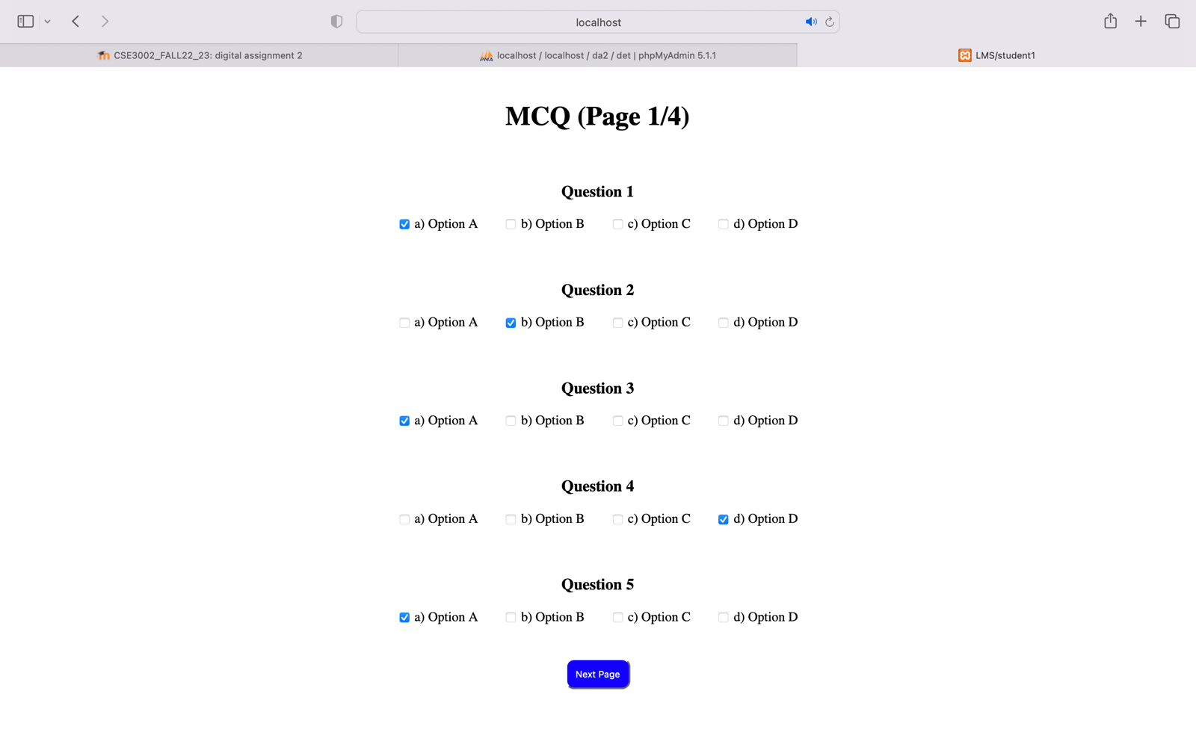

<?php

$con = mysqli_connect("localhost", "root", "", "da2");

if($con-> connect_error)

die("connection failed:".$con->connect_error);

if(isset($_POST['submit'])) {

if(!empty($_POST['ques6'])){

$insert = false;

foreach($_POST['ques6'] as $ques6){

$sql = "INSERT INTO `da2`.`mcqea` (`enteredans`, `date`) VALUES ('$ques6', current_timestamp());";

if($con->query($sql) == true){

$insert = true;

}

}

}

if(!empty($_POST['ques7'])){

$insert = false;

foreach($_POST['ques7'] as $ques7){

$sql = "INSERT INTO `da2`.`mcqea` (`enteredans`, `date`) VALUES ('$ques7', current_timestamp());";

if($con->query($sql) == true){

$insert = true;

}

}

}

if(!empty($_POST['ques8'])){

$insert = false;

foreach($_POST['ques8'] as $ques8){

$sql = "INSERT INTO `da2`.`mcqea` (`enteredans`, `date`) VALUES ('$ques8', current_timestamp());";

if($con->query($sql) == true){

$insert = true;

}

}

}

if(!empty($_POST['ques9'])){

$insert = false;

foreach($_POST['ques9'] as $ques9){

$sql = "INSERT INTO `da2`.`mcqea` (`enteredans`, `date`) VALUES ('$ques9', current_timestamp());";

if($con->query($sql) == true){

$insert = true;

}

}

}

if(!empty($_POST['ques10'])){

$insert = false;

foreach($_POST['ques10'] as $ques10){

$sql = "INSERT INTO `da2`.`mcqea` (`enteredans`, `date`) VALUES ('$ques10', current_timestamp());";

if($con->query($sql) == true){

$insert = true;

}

}

}

header("Location:http://localhost/IWP_DA2/student3.php");

}

$con->close();

?>

<!DOCTYPE html>

<html lang="en">

<head>

<meta charset="UTF-8">

<meta http-equiv="X-UA-Compatible" content="IE=edge">

<meta name="viewport" content="wvalueth=device-wvalueth, initial-scale=1.0">

<title>LMS/student2</title>

<style>

h1{

text-align: center;

padding-top: 20px;

}

h3{

padding-top: 40px;

}

input[type="submit"]{

margin: 10px;

padding: 10px;

border-radius: 10px;

background-color: rgb(17, 0, 255);

color: white;

margin-top: 40px;

}

input[type="submit"]:hover{

background-color: rgb(0, 0, 0);

}

</style>

</head>

<body>

<div>

<h1>MCQ (Page 2/4)</h1>

<form align="center" action="student2.php" method="POST">

<h3>Question 6</h3>

<input type="checkbox" value="OptA" name="ques6[]">

<label for="OptA">a) Option A</label>&nbsp;&nbsp;&nbsp;&nbsp;&nbsp;&nbsp;&nbsp;

<input type="checkbox" value="OptB" name="ques6[]">

<label for="OptB">b) Option B</label>&nbsp;&nbsp;&nbsp;&nbsp;&nbsp;&nbsp;&nbsp;

<input type="checkbox" value="OptC" name="ques6[]">

<label for="OptC">c) Option C</label>&nbsp;&nbsp;&nbsp;&nbsp;&nbsp;&nbsp;&nbsp;

<input type="checkbox" value="OptD" name="ques6[]">

<label for="OptD">d) Option D</label>

<h3>Question 7</h3>

<input type="checkbox" value="OptA" name="ques7[]">

<label for="OptA">a) Option A</label>&nbsp;&nbsp;&nbsp;&nbsp;&nbsp;&nbsp;&nbsp;

<input type="checkbox" value="OptB" name="ques7[]">

<label for="OptB">b) Option B</label>&nbsp;&nbsp;&nbsp;&nbsp;&nbsp;&nbsp;&nbsp;

<input type="checkbox" value="OptC" name="ques7[]">

<label for="OptC">c) Option C</label>&nbsp;&nbsp;&nbsp;&nbsp;&nbsp;&nbsp;&nbsp;

<input type="checkbox" value="OptD" name="ques7[]">

<label for="OptD">d) Option D</label>

<h3>Question 8</h3>

<input type="checkbox" value="OptA" name="ques8[]">

<label for="OptA">a) Option A</label>&nbsp;&nbsp;&nbsp;&nbsp;&nbsp;&nbsp;&nbsp;

<input type="checkbox" value="OptB" name="ques8[]">

<label for="OptB">b) Option B</label>&nbsp;&nbsp;&nbsp;&nbsp;&nbsp;&nbsp;&nbsp;

<input type="checkbox" value="OptC" name="ques8[]">

<label for="OptC">c) Option C</label>&nbsp;&nbsp;&nbsp;&nbsp;&nbsp;&nbsp;&nbsp;

<input type="checkbox" value="OptD" name="ques8[]">

<label for="OptD">d) Option D</label>

<h3>Question 9</h3>

<input type="checkbox" value="OptA" name="ques9[]">

<label for="OptA">a) Option A</label>&nbsp;&nbsp;&nbsp;&nbsp;&nbsp;&nbsp;&nbsp;

<input type="checkbox" value="OptB" name="ques9[]">

<label for="OptB">b) Option B</label>&nbsp;&nbsp;&nbsp;&nbsp;&nbsp;&nbsp;&nbsp;

<input type="checkbox" value="OptC" name="ques9[]">

<label for="OptC">c) Option C</label>&nbsp;&nbsp;&nbsp;&nbsp;&nbsp;&nbsp;&nbsp;

<input type="checkbox" value="OptD" name="ques9[]">

<label for="OptD">d) Option D</label>

<h3>Question 10</h3>

<input type="checkbox" value="OptA" name="ques10[]">

<label for="OptA">a) Option A</label>&nbsp;&nbsp;&nbsp;&nbsp;&nbsp;&nbsp;&nbsp;

<input type="checkbox" value="OptB" name="ques10[]">

<label for="OptB">b) Option B</label>&nbsp;&nbsp;&nbsp;&nbsp;&nbsp;&nbsp;&nbsp;

<input type="checkbox" value="OptC" name="ques10[]">

<label for="OptC">c) Option C</label>&nbsp;&nbsp;&nbsp;&nbsp;&nbsp;&nbsp;&nbsp;

<input type="checkbox" value="OptD" name="ques10[]">

<label for="OptD">d) Option D</label><br>

<input type="submit" name="submit" value="Next Page">

</form>

</div>

</body>

</html>

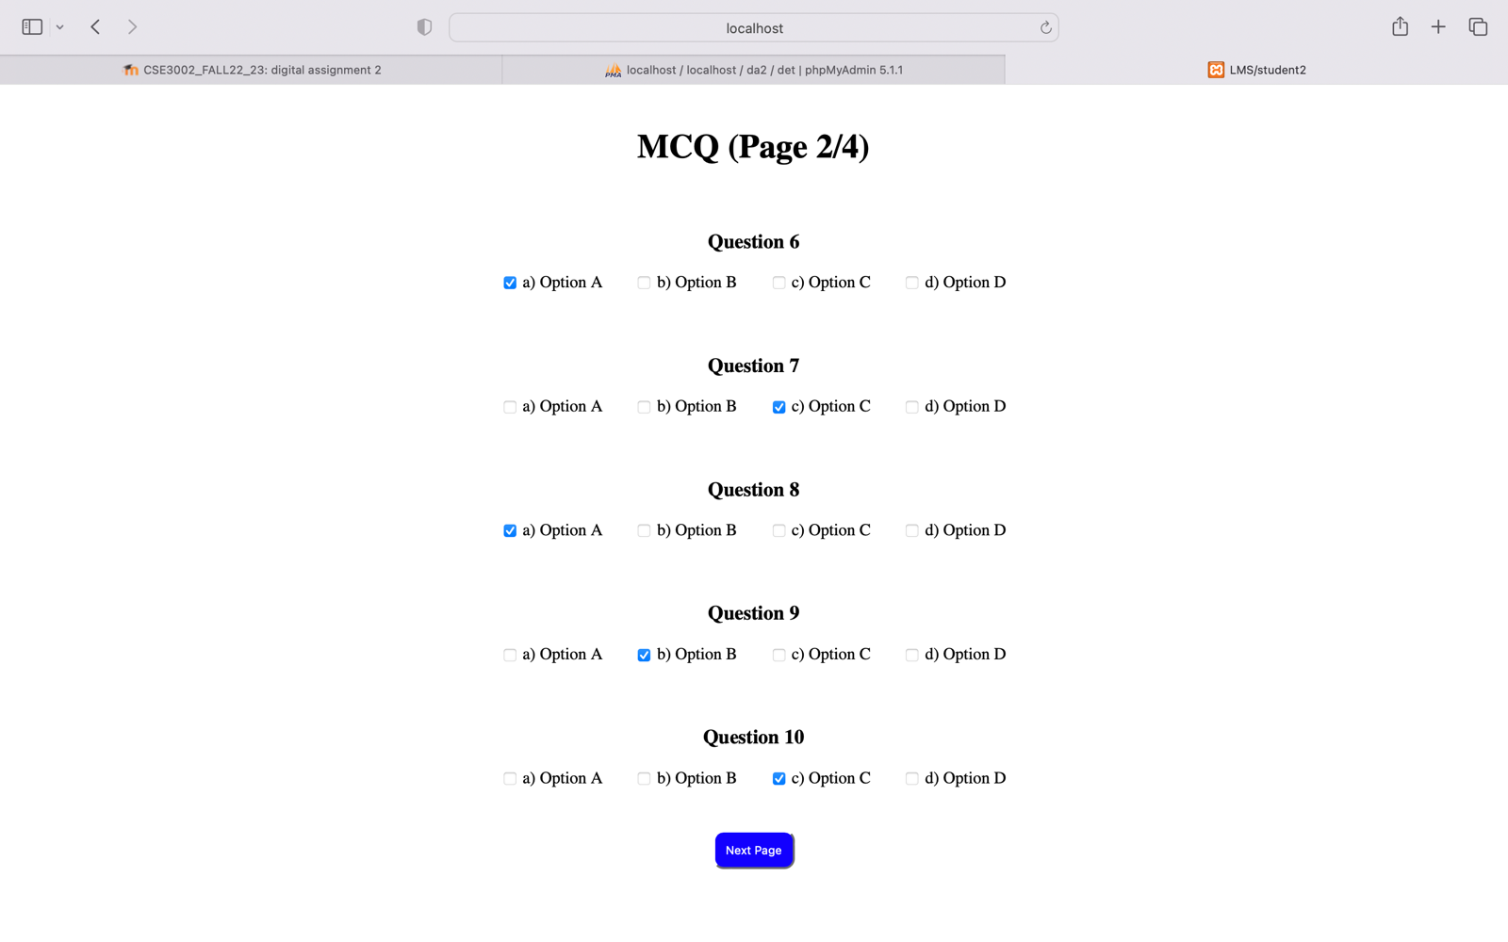

<?php

$con = mysqli_connect("localhost", "root", "", "da2");

if($con-> connect_error)

die("connection failed:".$con->connect_error);

if(isset($_POST['submit'])) {

if(!empty($_POST['ques11'])){

$insert = false;

foreach($_POST['ques11'] as $ques11){

$sql = "INSERT INTO `da2`.`mcqea` (`enteredans`, `date`) VALUES ('$ques11', current_timestamp());";

if($con->query($sql) == true){

$insert = true;

}

}

}

if(!empty($_POST['ques12'])){

$insert = false;

foreach($_POST['ques12'] as $ques12){

$sql = "INSERT INTO `da2`.`mcqea` (`enteredans`, `date`) VALUES ('$ques12', current_timestamp());";

if($con->query($sql) == true){

$insert = true;

}

}

}

if(!empty($_POST['ques13'])){

$insert = false;

foreach($_POST['ques13'] as $ques13){

$sql = "INSERT INTO `da2`.`mcqea` (`enteredans`, `date`) VALUES ('$ques13', current_timestamp());";

if($con->query($sql) == true){

$insert = true;

}

}

}

if(!empty($_POST['ques14'])){

$insert = false;

foreach($_POST['ques14'] as $ques14){

$sql = "INSERT INTO `da2`.`mcqea` (`enteredans`, `date`) VALUES ('$ques14', current_timestamp());";

if($con->query($sql) == true){

$insert = true;

}

}

}

if(!empty($_POST['ques15'])){

$insert = false;

foreach($_POST['ques15'] as $ques15){

$sql = "INSERT INTO `da2`.`mcqea` (`enteredans`, `date`) VALUES ('$ques15', current_timestamp());";

if($con->query($sql) == true){

$insert = true;

}

}

}

header("Location:http://localhost/IWP_DA2/student4.php");

}

$con->close();

?>

<!DOCTYPE html>

<html lang="en">

<head>

<meta charset="UTF-8">

<meta http-equiv="X-UA-Compatible" content="IE=edge">

<meta name="viewport" content="wvalueth=device-wvalueth, initial-scale=1.0">

<title>LMS/student3</title>

<style>

h1{

text-align: center;

padding-top: 20px;

}

h3{

padding-top: 40px;

}

input[type="submit"]{

margin: 10px;

padding: 10px;

border-radius: 10px;

background-color: rgb(17, 0, 255);

color: white;

margin-top: 40px;

}

input[type="submit"]:hover{

background-color: rgb(0, 0, 0);

}

</style>

</head>

<body>

<div>

<h1>MCQ (Page 3/4)</h1>

<form align="center" action="student3.php" method="POST">

<h3>Question 11</h3>

<input type="checkbox" value="OptA" name="ques11[]">

<label for="OptA">a) Option A</label>&nbsp;&nbsp;&nbsp;&nbsp;&nbsp;&nbsp;&nbsp;

<input type="checkbox" value="OptB" name="ques11[]">

<label for="OptB">b) Option B</label>&nbsp;&nbsp;&nbsp;&nbsp;&nbsp;&nbsp;&nbsp;

<input type="checkbox" value="OptC" name="ques11[]">

<label for="OptC">c) Option C</label>&nbsp;&nbsp;&nbsp;&nbsp;&nbsp;&nbsp;&nbsp;

<input type="checkbox" value="OptD" name="ques11[]">

<label for="OptD">d) Option D</label>

<h3>Question 12</h3>

<input type="checkbox" value="OptA" name="ques12[]">

<label for="OptA">a) Option A</label>&nbsp;&nbsp;&nbsp;&nbsp;&nbsp;&nbsp;&nbsp;

<input type="checkbox" value="OptB" name="ques12[]">

<label for="OptB">b) Option B</label>&nbsp;&nbsp;&nbsp;&nbsp;&nbsp;&nbsp;&nbsp;

<input type="checkbox" value="OptC" name="ques12[]">

<label for="OptC">c) Option C</label>&nbsp;&nbsp;&nbsp;&nbsp;&nbsp;&nbsp;&nbsp;

<input type="checkbox" value="OptD" name="ques12[]">

<label for="OptD">d) Option D</label>

<h3>Question 13</h3>

<input type="checkbox" value="OptA" name="ques13[]">

<label for="OptA">a) Option A</label>&nbsp;&nbsp;&nbsp;&nbsp;&nbsp;&nbsp;&nbsp;

<input type="checkbox" value="OptB" name="ques13[]">

<label for="OptB">b) Option B</label>&nbsp;&nbsp;&nbsp;&nbsp;&nbsp;&nbsp;&nbsp;

<input type="checkbox" value="OptC" name="ques13[]">

<label for="OptC">c) Option C</label>&nbsp;&nbsp;&nbsp;&nbsp;&nbsp;&nbsp;&nbsp;

<input type="checkbox" value="OptD" name="ques13[]">

<label for="OptD">d) Option D</label>

<h3>Question 14</h3>

<input type="checkbox" value="OptA" name="ques14[]">

<label for="OptA">a) Option A</label>&nbsp;&nbsp;&nbsp;&nbsp;&nbsp;&nbsp;&nbsp;

<input type="checkbox" value="OptB" name="ques14[]">

<label for="OptB">b) Option B</label>&nbsp;&nbsp;&nbsp;&nbsp;&nbsp;&nbsp;&nbsp;

<input type="checkbox" value="OptC" name="ques14[]">

<label for="OptC">c) Option C</label>&nbsp;&nbsp;&nbsp;&nbsp;&nbsp;&nbsp;&nbsp;

<input type="checkbox" value="OptD" name="ques14[]">

<label for="OptD">d) Option D</label>

<h3>Question 15</h3>

<input type="checkbox" value="OptA" name="ques15[]">

<label for="OptA">a) Option A</label>&nbsp;&nbsp;&nbsp;&nbsp;&nbsp;&nbsp;&nbsp;

<input type="checkbox" value="OptB" name="ques15[]">

<label for="OptB">b) Option B</label>&nbsp;&nbsp;&nbsp;&nbsp;&nbsp;&nbsp;&nbsp;

<input type="checkbox" value="OptC" name="ques15[]">

<label for="OptC">c) Option C</label>&nbsp;&nbsp;&nbsp;&nbsp;&nbsp;&nbsp;&nbsp;

<input type="checkbox" value="OptD" name="ques15[]">

<label for="OptD">d) Option D</label><br>

<input type="submit" name="submit" value="Next Page">

</form>

</div>

</body>

</html>

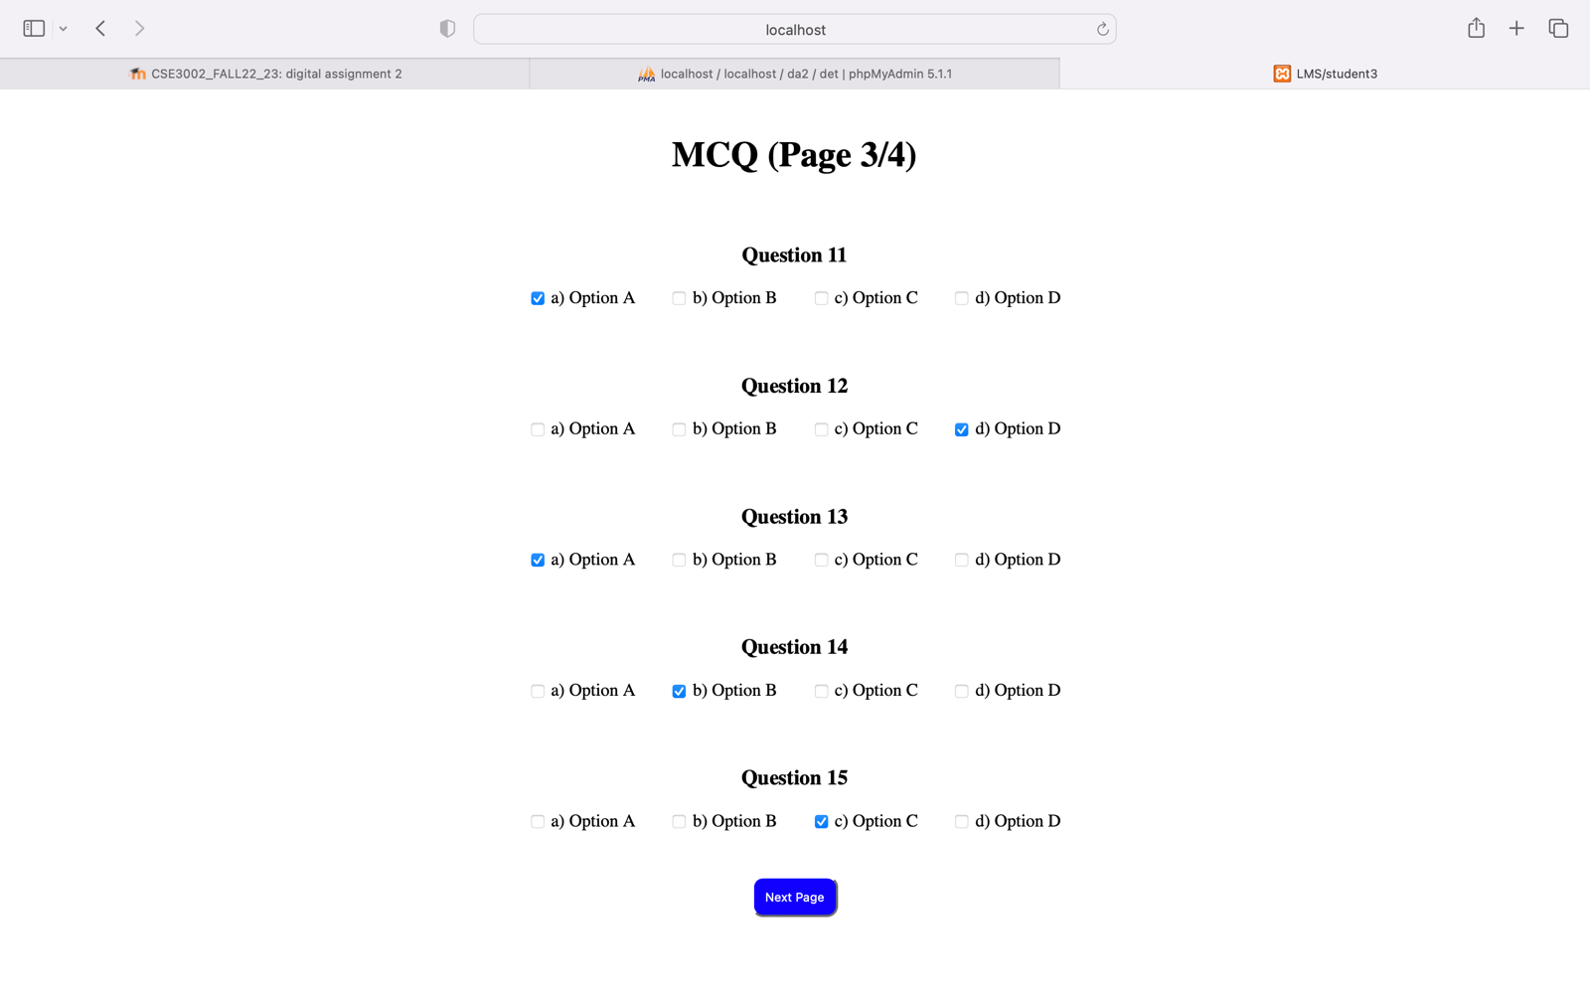

<?php

$con = mysqli_connect("localhost", "root", "", "da2");

if($con-> connect_error)

die("connection failed:".$con->connect_error);

if(isset($_POST['submit'])) {

if(!empty($_POST['ques16'])){

$insert = false;

foreach($_POST['ques16'] as $ques16){

$sql = "INSERT INTO `da2`.`mcqea` (`enteredans`, `date`) VALUES ('$ques16', current_timestamp());";

if($con->query($sql) == true){

$insert = true;

}

}

}

if(!empty($_POST['ques17'])){

$insert = false;

foreach($_POST['ques17'] as $ques17){

$sql = "INSERT INTO `da2`.`mcqea` (`enteredans`, `date`) VALUES ('$ques17', current_timestamp());";

if($con->query($sql) == true){

$insert = true;

}

}

}

if(!empty($_POST['ques18'])){

$insert = false;

foreach($_POST['ques18'] as $ques18){

$sql = "INSERT INTO `da2`.`mcqea` (`enteredans`, `date`) VALUES ('$ques18', current_timestamp());";

if($con->query($sql) == true){

$insert = true;

}

}

}

if(!empty($_POST['ques19'])){

$insert = false;

foreach($_POST['ques19'] as $ques19){

$sql = "INSERT INTO `da2`.`mcqea` (`enteredans`, `date`) VALUES ('$ques19', current_timestamp());";

if($con->query($sql) == true){

$insert = true;

}

}

}

if(!empty($_POST['ques20'])){

$insert = false;

foreach($_POST['ques20'] as $ques20){

$sql = "INSERT INTO `da2`.`mcqea` (`enteredans`, `date`) VALUES ('$ques20', current_timestamp());";

if($con->query($sql) == true){

$insert = true;

}

}

}

header("Location:http://localhost/IWP_DA2/student5.php");

}

$con->close();

?>

<!DOCTYPE html>

<html lang="en">

<head>

<meta charset="UTF-8">

<meta http-equiv="X-UA-Compatible" content="IE=edge">

<meta name="viewport" content="wvalueth=device-wvalueth, initial-scale=1.0">

<title>LMS/student4</title>

<style>

h1{

text-align: center;

padding-top: 20px;

}

h3{

padding-top: 40px;

}

input[type="submit"]{

margin: 10px;

padding: 10px;

border-radius: 10px;

background-color: rgb(17, 0, 255);

color: white;

margin-top: 40px;

}

input[type="submit"]:hover{

background-color: rgb(0, 0, 0);

}

</style>

</head>

<body>

<div>

<h1>MCQ (Page 4/4)</h1>

<form align="center" action="student4.php" method="POST">

<h3>Question 16</h3>

<input type="checkbox" value="OptA" name="ques16[]">

<label for="OptA">a) Option A</label>&nbsp;&nbsp;&nbsp;&nbsp;&nbsp;&nbsp;&nbsp;

<input type="checkbox" value="OptB" name="ques16[]">

<label for="OptB">b) Option B</label>&nbsp;&nbsp;&nbsp;&nbsp;&nbsp;&nbsp;&nbsp;

<input type="checkbox" value="OptC" name="ques16[]">

<label for="OptC">c) Option C</label>&nbsp;&nbsp;&nbsp;&nbsp;&nbsp;&nbsp;&nbsp;

<input type="checkbox" value="OptD" name="ques16[]">

<label for="OptD">d) Option D</label>

<h3>Question 17</h3>

<input type="checkbox" value="OptA" name="ques17[]">

<label for="OptA">a) Option A</label>&nbsp;&nbsp;&nbsp;&nbsp;&nbsp;&nbsp;&nbsp;

<input type="checkbox" value="OptB" name="ques17[]">

<label for="OptB">b) Option B</label>&nbsp;&nbsp;&nbsp;&nbsp;&nbsp;&nbsp;&nbsp;

<input type="checkbox" value="OptC" name="ques17[]">

<label for="OptC">c) Option C</label>&nbsp;&nbsp;&nbsp;&nbsp;&nbsp;&nbsp;&nbsp;

<input type="checkbox" value="OptD" name="ques17[]">

<label for="OptD">d) Option D</label>

<h3>Question 18</h3>

<input type="checkbox" value="OptA" name="ques18[]">

<label for="OptA">a) Option A</label>&nbsp;&nbsp;&nbsp;&nbsp;&nbsp;&nbsp;&nbsp;

<input type="checkbox" value="OptB" name="ques18[]">

<label for="OptB">b) Option B</label>&nbsp;&nbsp;&nbsp;&nbsp;&nbsp;&nbsp;&nbsp;

<input type="checkbox" value="OptC" name="ques18[]">

<label for="OptC">c) Option C</label>&nbsp;&nbsp;&nbsp;&nbsp;&nbsp;&nbsp;&nbsp;

<input type="checkbox" value="OptD" name="ques18[]">

<label for="OptD">d) Option D</label>

<h3>Question 19</h3>

<input type="checkbox" value="OptA" name="ques19[]">

<label for="OptA">a) Option A</label>&nbsp;&nbsp;&nbsp;&nbsp;&nbsp;&nbsp;&nbsp;

<input type="checkbox" value="OptB" name="ques19[]">

<label for="OptB">b) Option B</label>&nbsp;&nbsp;&nbsp;&nbsp;&nbsp;&nbsp;&nbsp;

<input type="checkbox" value="OptC" name="ques19[]">

<label for="OptC">c) Option C</label>&nbsp;&nbsp;&nbsp;&nbsp;&nbsp;&nbsp;&nbsp;

<input type="checkbox" value="OptD" name="ques19[]">

<label for="OptD">d) Option D</label>

<h3>Question 20</h3>

<input type="checkbox" value="OptA" name="ques20[]">

<label for="OptA">a) Option A</label>&nbsp;&nbsp;&nbsp;&nbsp;&nbsp;&nbsp;&nbsp;

<input type="checkbox" value="OptB" name="ques20[]">

<label for="OptB">b) Option B</label>&nbsp;&nbsp;&nbsp;&nbsp;&nbsp;&nbsp;&nbsp;

<input type="checkbox" value="OptC" name="ques20[]">

<label for="OptC">c) Option C</label>&nbsp;&nbsp;&nbsp;&nbsp;&nbsp;&nbsp;&nbsp;

<input type="checkbox" value="OptD" name="ques20[]">

<label for="OptD">d) Option D</label><br>

<input type="submit" name="submit" value="Submit">

</form>

</div>

</body>

</html>

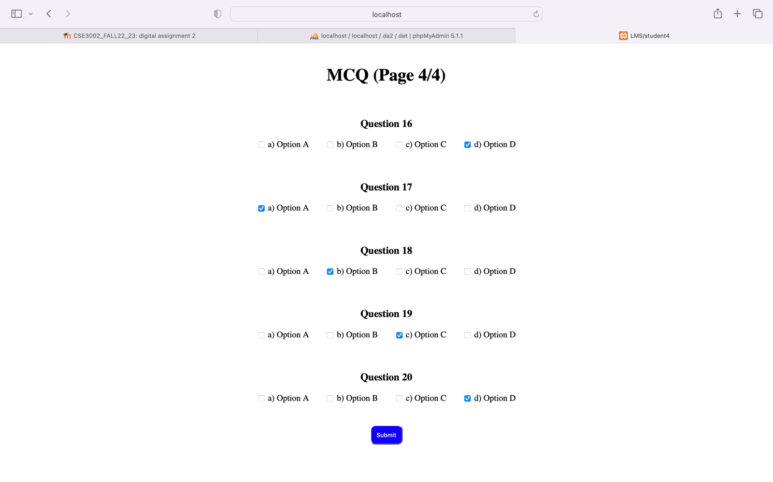

<?php

$con = mysqli_connect("localhost", "root", "", "da2");

if($con-> connect_error) {

die("connection failed:".$con->connect_error);

}

$crctans = array("OptA","OptB","OptC","OptD","OptA","OptB","OptC","OptD","OptA","OptB","OptC","OptD","OptA","OptB","OptC","OptD","OptA","OptB","OptC","OptD");

$query = "SELECT enteredans from mcqea";

$result = mysqli_query($con,$query);

$i=0;

$count=0;

while($row = mysqli_fetch_array($result)){

if($row['enteredans']==$crctans[$i]){

$count++;

}

$i++;

}

echo "<center><B><p style='font-size:40px;padding:300px'>Marks Scored: $count/20</p></B></center>";

$con->close();

?>

<!DOCTYPE html>

<html lang="en">

<head>

<meta charset="UTF-8">

<meta http-equiv="X-UA-Compatible" content="IE=edge">

<meta name="viewport" content="width=device-width, initial-scale=1.0">

<title>LMS/student5</title>

</head>

<body>

</body>

</html>

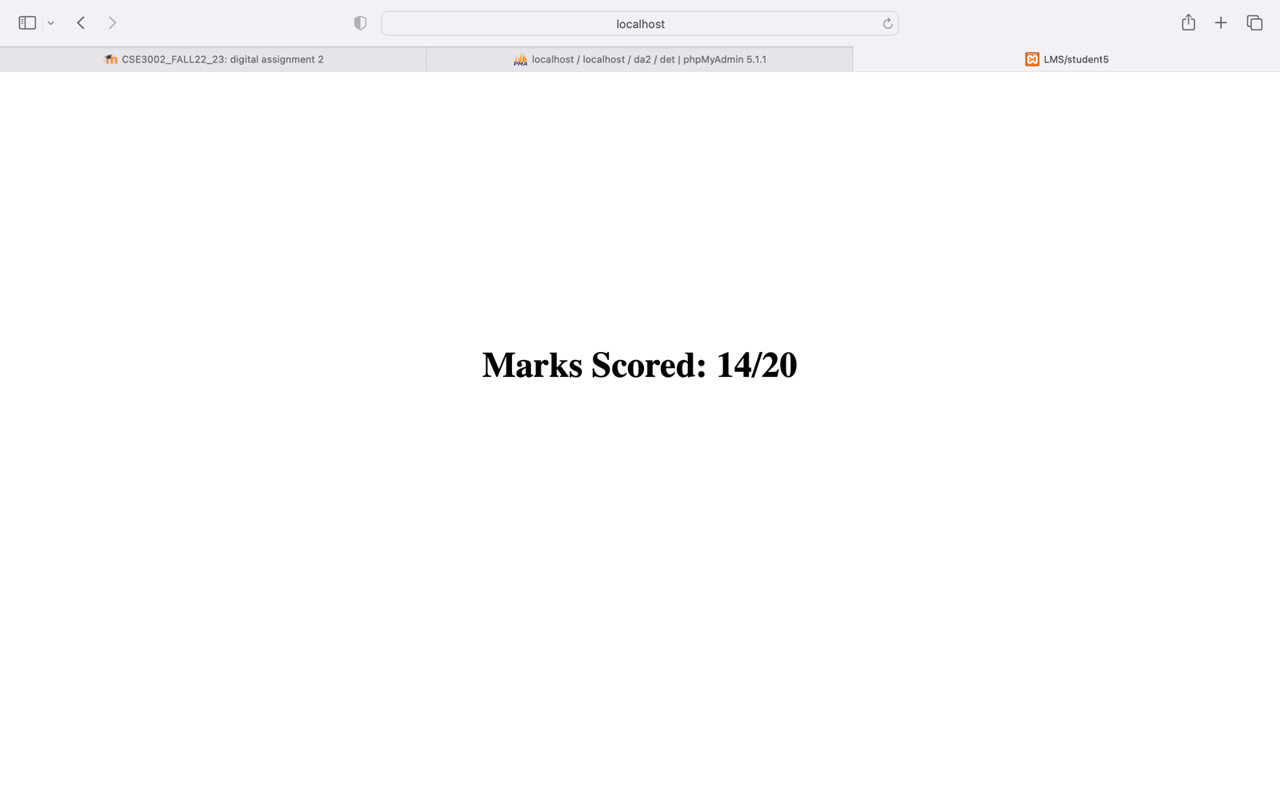

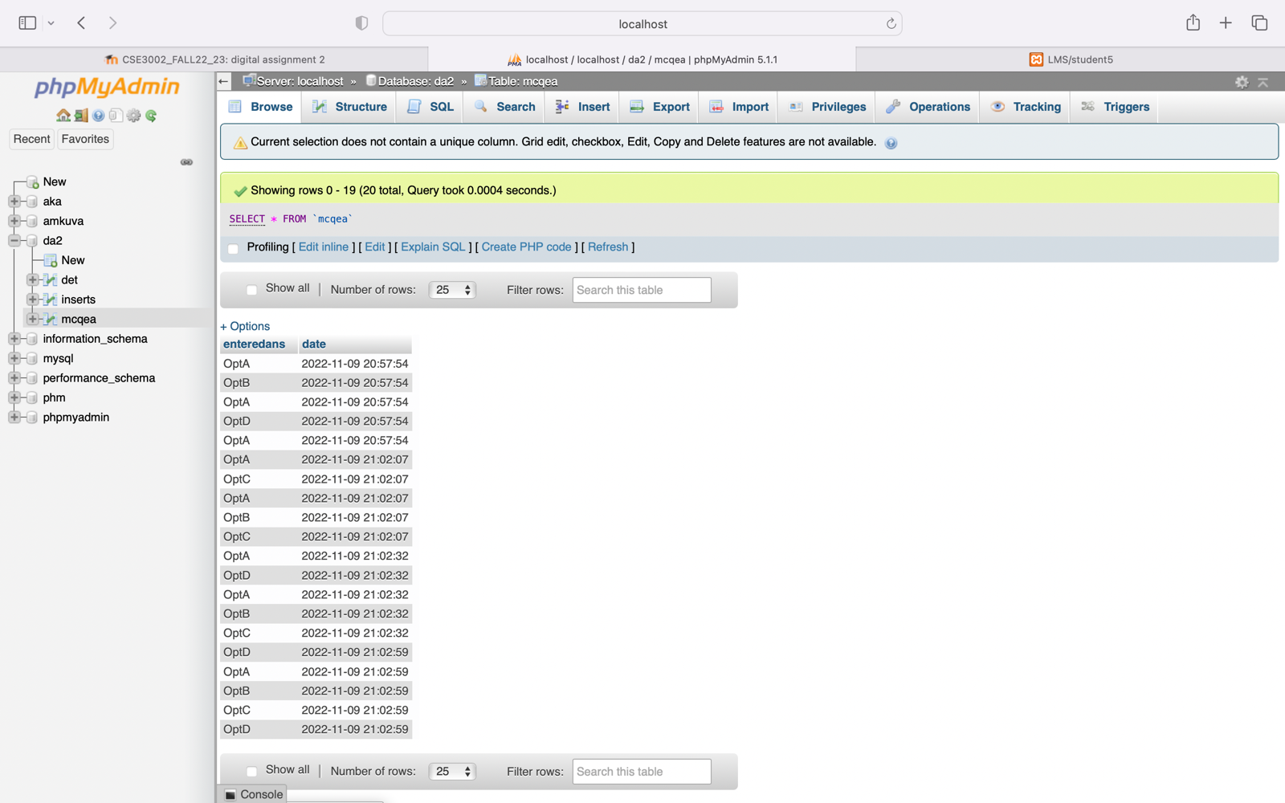

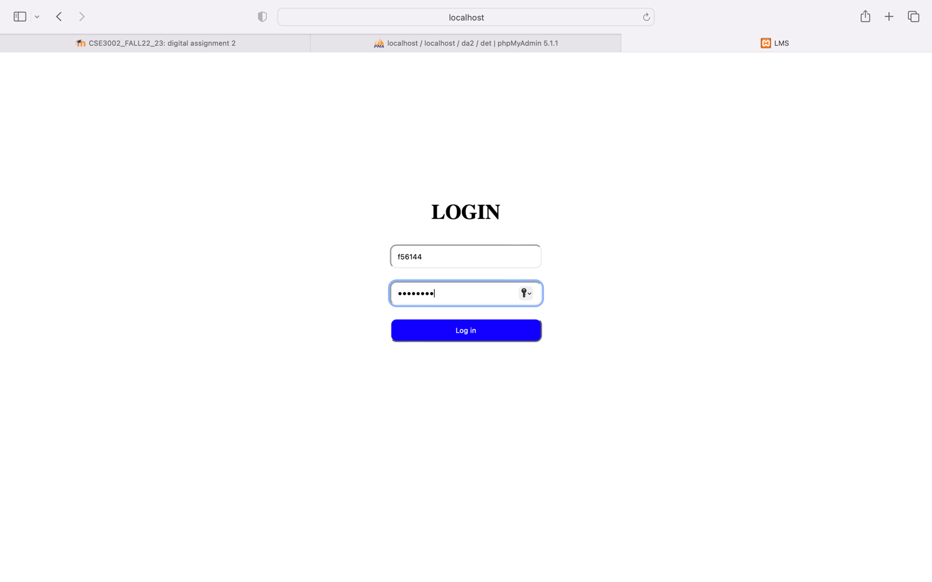

<!DOCTYPE html>

<html lang="en">

<head>

<meta charset="UTF-8">

<meta http-equiv="X-UA-Compatible" content="IE=edge">

<meta name="viewport" content="width=device-width, initial-scale=1.0">

<title>LMS/faculty</title>

<style>

body{

margin-top: 250px;

}

a{

text-decoration: none;

font-size: 30px;

color: white;

}

button{

border-radius: 10px;

width: 400px;

padding: 10px;

background-color: rgb(17, 0, 255);

}

button:hover{

background-color: rgb(0, 0, 0);

}

</style>

</head>

<body>

<center>

<button><a href="http://localhost/IWP_DA2/faculty1.html">Upload Question</a></button><br>

<button><a href="http://localhost/IWP_DA2/faculty2.php">Send Outing Mail</a></button><br>

<button><a href="http://localhost/IWP_DA2/faculty3.html">Modify Marks</a></button>

</center>

</body>

</html>

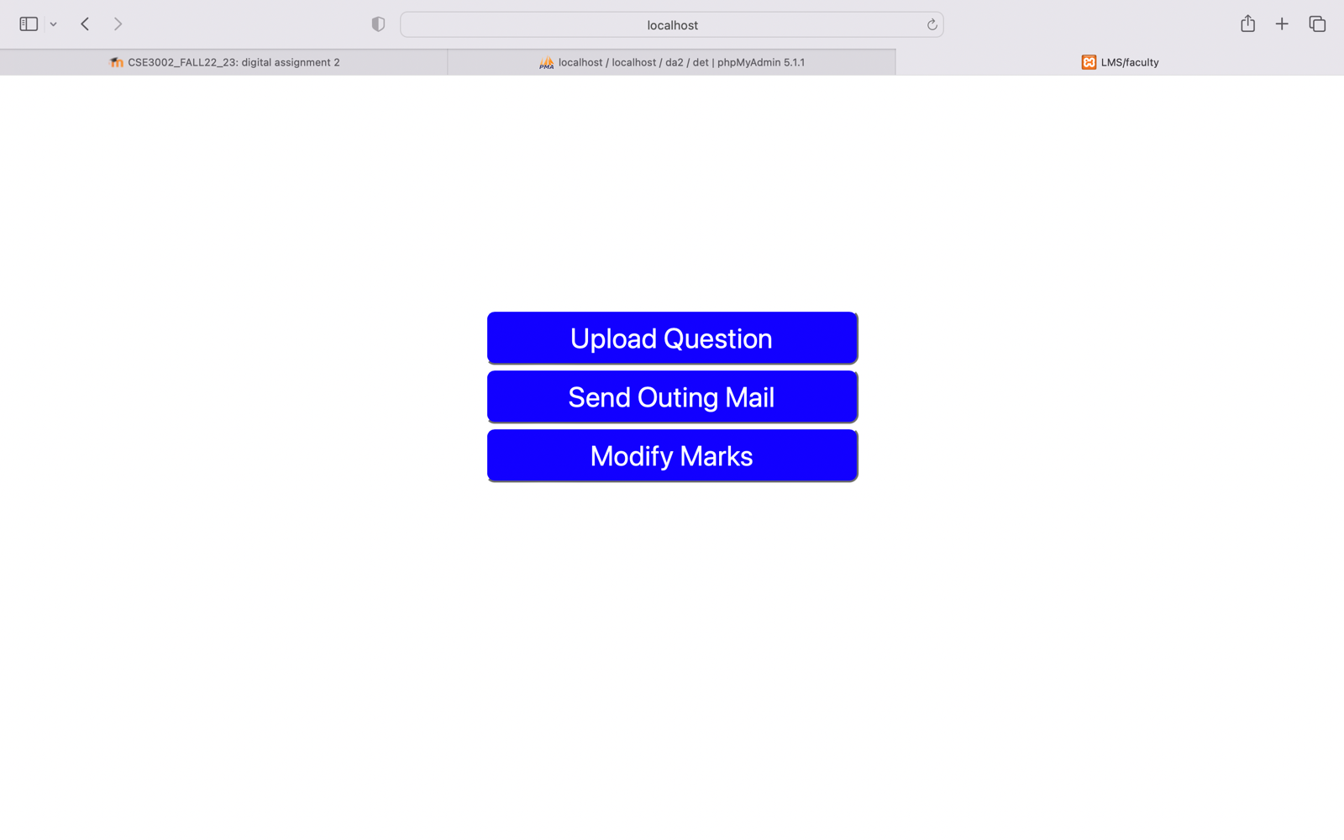

<!DOCTYPE html>

<html lang="en">

<head>

<meta charset="UTF-8">

<meta http-equiv="X-UA-Compatible" content="IE=edge">

<meta name="viewport" content="width=device-width, initial-scale=1.0">

<title>LMS/faculty/question</title>

<style>

h1{

text-align: center;

}

input[type="submit"]{

margin: 10px;

padding: 10px;

border-radius: 10px;

}

div{

padding-top: 250px;

}

input[type="submit"]{

background-color: rgb(17, 0, 255);

color: white;

}

input[type="submit"]:hover{

background-color: rgb(0, 0, 0);

}

</style>

</head>

<body>

<div>

<h1>UPLOAD QUESTION</h1><br>

<form align="center">

<input type="file" name="ques" id="ques"><br><br>

<input type="submit" value="Upload">

</form>

</div>

</body>

</html>

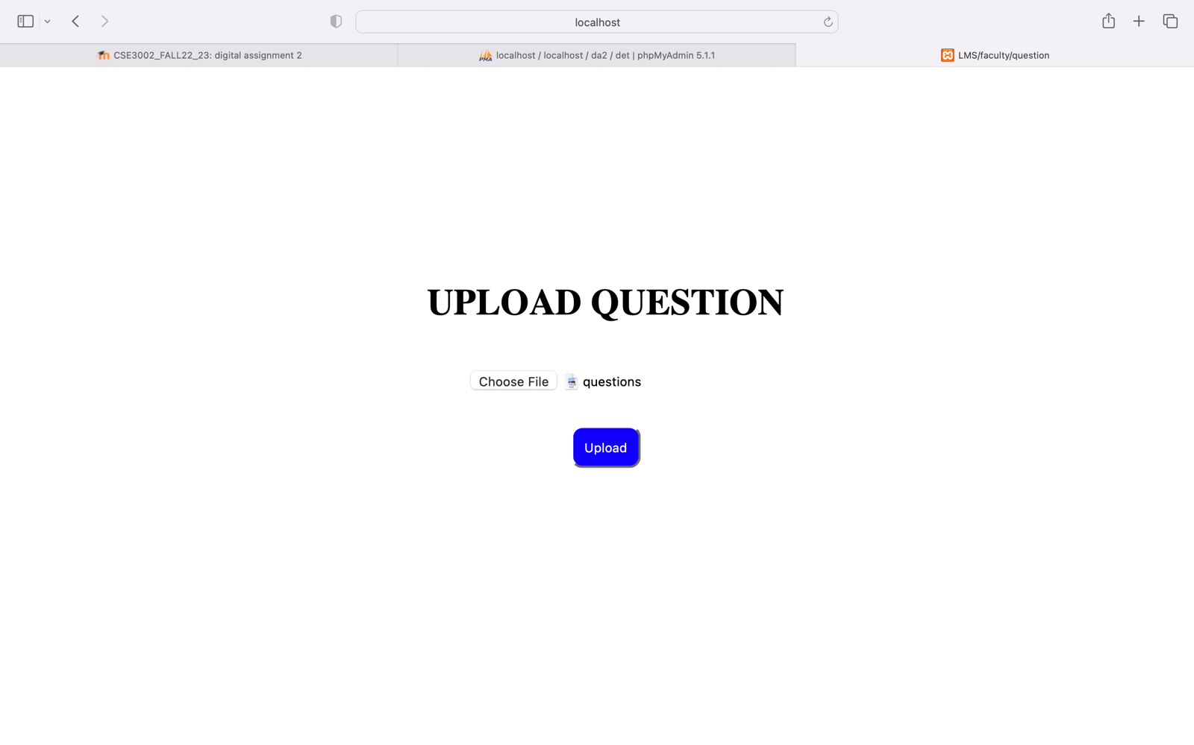

<?php

$to = "cw.cc@vit.ac.in";

$subject = $_POST['sub'];

$txt = $_POST['msg'];

$headers = "From: proctor@vit.ac.in" . "\r\n" .

"CC: cso.cc@vit.ac.in";

mail($to,$subject,$txt,$headers);

?>

<!DOCTYPE html>

<html lang="en">

<head>

<meta charset="UTF-8">

<meta http-equiv="X-UA-Compatible" content="IE=edge">

<meta name="viewport" content="width=device-width, initial-scale=1.0">

<title>LMS/faculty/mail</title>

<style>

div{

text-align: center;

padding-top: 130px;

}

input[type="text"],[type="submit"],textarea{

margin: 10px;

padding: 10px;

border-radius: 10px;

}

input[type="submit"]{

background-color: rgb(17, 0, 255);

color: white;

}

input[type="submit"]:hover{

background-color: rgb(0, 0, 0);

}

</style>

</head>

<body>

<div>

<h1>OUTING APPROVAL MAIL</h1>

<form action="faculty2.php" method="POST">

<input type="text" name="sub" id="sub" placeholder="Subject" size="77"><br>

<textarea name="msg" id="msg" placeholder="Mail content" rows="15" cols="75"></textarea><br>

<input type="submit" value="Mail">

</form>

</div>

</body>

</html>

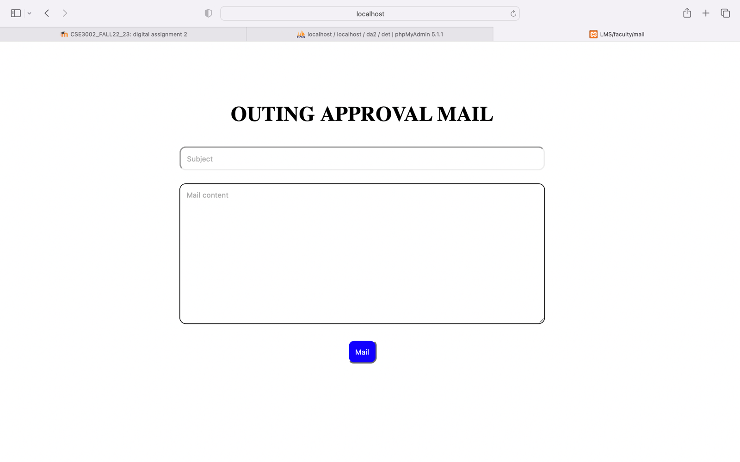

<!DOCTYPE html>

<html lang="en">

<head>

<meta charset="UTF-8">

<meta http-equiv="X-UA-Compatible" content="IE=edge">

<meta name="viewport" content="width=device-width, initial-scale=1.0">

<title>LMS/faculty/faculty3</title>

<style>

body{

margin-top: 250px;

}

a{

text-decoration: none;

font-size: 30px;

color: white;

}

button{

border-radius: 10px;

width: 400px;

padding: 10px;

background-color: rgb(17, 0, 255);

}

button:hover{

background-color: rgb(0, 0, 0);

}

</style>

</head>

<body>

<center>

<button><a href="http://localhost/IWP_DA2/insert.php">Insert Marks</a></button><br>

<button><a href="http://localhost/IWP_DA2/update.php">Update Marks</a></button><br>

<button><a href="http://localhost/IWP_DA2/delete.php">Delete Marks</a></button><br>

<button><a href="http://localhost/IWP_DA2/smft.php">Sort Marks & Find Topper</a></button>

</center>

</body>

</html>

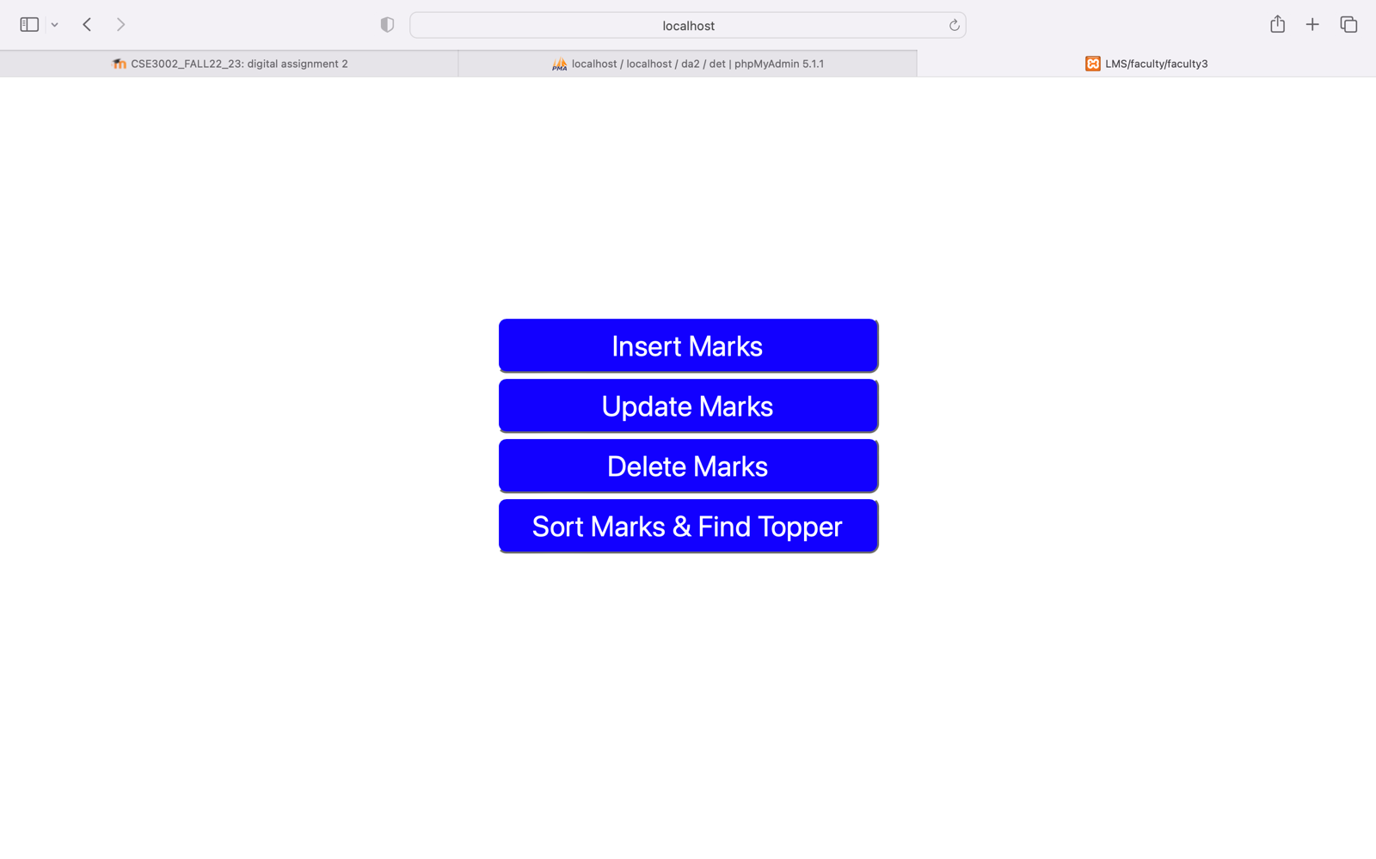

<?php

$insert = false;

if(isset($_POST['sno'])){

$server = "localhost";

$username = "root";

$password = "";

$con = mysqli_connect($server, $username, $password);

if(!$con){

die("connection to this database failed due to" . mysqli_connect_error());

}

$sno = $_POST['sno'];

$names = $_POST['names'];

$sql = "INSERT INTO `da2`.`inserts` (`sno`, `names`, `date`) VALUES ('$sno', '$names', current_timestamp());";

if($con->query($sql) == true){

echo "<I><B>Successfully inserted...</B></I>";

$insert = true;

}

else{

echo "ERROR: $sql <br> $con->error";

}

$con->close();

}

?>

<!DOCTYPE html>

<html lang="en">

<head>

<meta charset="UTF-8">

<meta http-equiv="X-UA-Compatible" content="IE=edge">

<meta name="viewport" content="width=device-width, initial-scale=1.0">

<title>LMS/faculty/faculty3/insert</title>

<style>

h1{

text-align: center;

}

input[type="submit"]{

margin: 10px;

padding: 10px;

border-radius: 10px;

}

input[type="text"],[type="number"]{

margin: 10px;

padding: 10px;

border-radius: 10px;

width: 200px;

}

div{

padding-top: 250px;

}

input[type="submit"]{

background-color: rgb(17, 0, 255);

color: white;

}

input[type="submit"]:hover{

background-color: rgb(0, 0, 0);

}

</style>

</head>

<body>

<div>

<h1>INSERT MARKS</h1>

<form align="center" action="insert.php" method="POST">

<input type="text" name="names" id="names" placeholder="Student's Name"><br>

<input type="number" name="sno" id="sno" placeholder="Student's Score"><br>

<input type="submit" value="Insert">

</form>

</div>

</body>

</html>

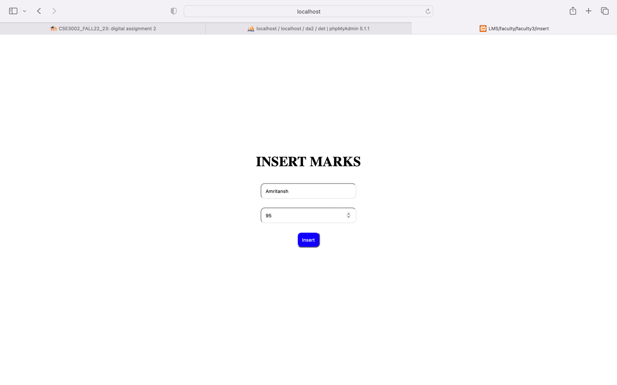

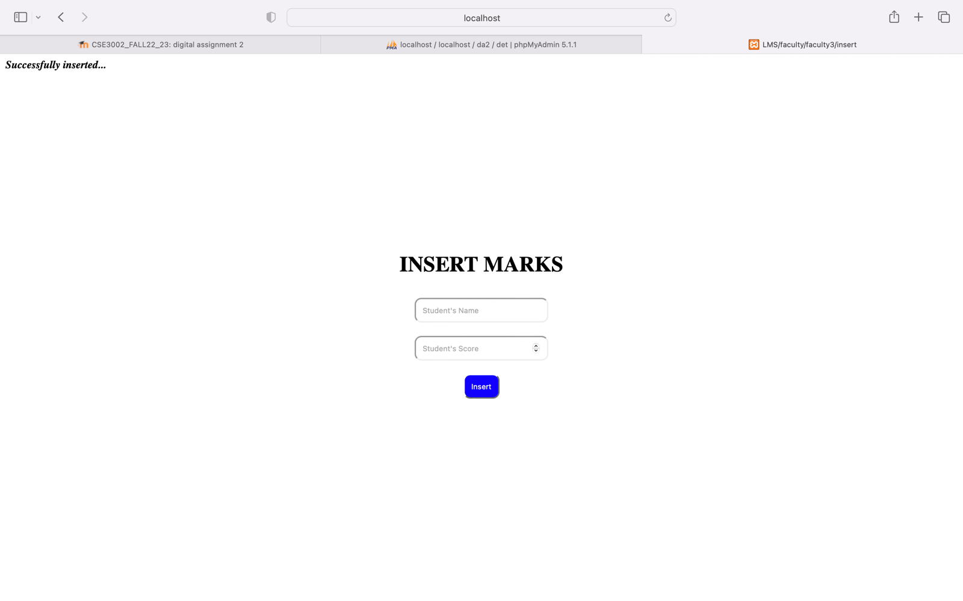

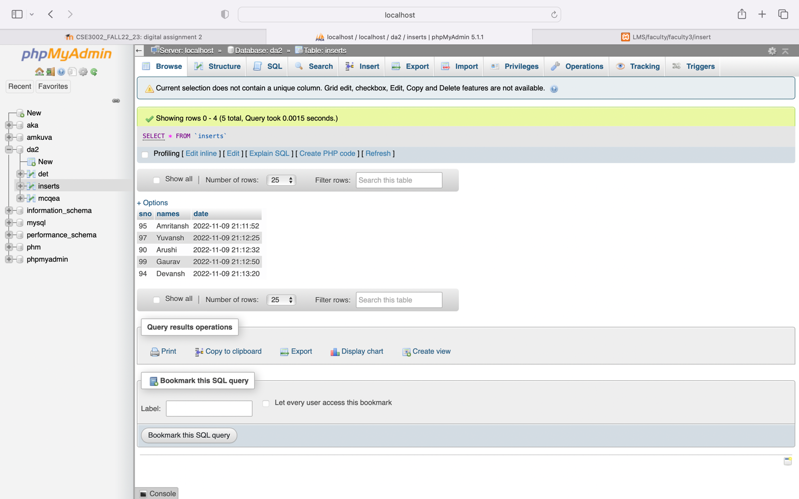

<?php

$insert = false;

if(isset($_POST['sno'])){

$conn = mysqli_connect("localhost", "root", "", "da2");

if($conn-> connect_error) {

die("connection failed:".$conn->connect_error);

}

$sno = $_POST['sno'];

$names = $_POST['names'];

$query = "UPDATE inserts SET `sno` = '$sno' where names='$names'";

$result = mysqli_query($conn,$query);

if($conn->query($query) == true){

echo "<I><B>Successfully updated...</B></I>";

}

else{

echo "ERROR: $query <br> $conn->error";

}

$conn->close();

}

?>

<!DOCTYPE html>

<html lang="en">

<head>

<meta charset="UTF-8">

<meta http-equiv="X-UA-Compatible" content="IE=edge">

<meta name="viewport" content="width=device-width, initial-scale=1.0">

<title>LMS/faculty/faculty3/update</title>

<style>

h1{

text-align: center;

}

input[type="submit"]{

margin: 10px;

padding: 10px;

border-radius: 10px;

}

input[type="text"],[type="number"]{

margin: 10px;

padding: 10px;

border-radius: 10px;

width: 200px;

}

div{

padding-top: 250px;

}

input[type="submit"]{

background-color: rgb(17, 0, 255);

color: white;

}

input[type="submit"]:hover{

background-color: rgb(0, 0, 0);

}

</style>

</head>

<body>

<div>

<h1>UPDATE MARKS</h1>

<form align="center" action="update.php" method="POST">

<input type="text" name="names" id="names" placeholder="Student's Name"><br>

<input type="number" name="sno" id="sno" placeholder="Updated Student's Score"><br>

<input type="submit" value="Update">

</form>

</div>

</body>

</html>

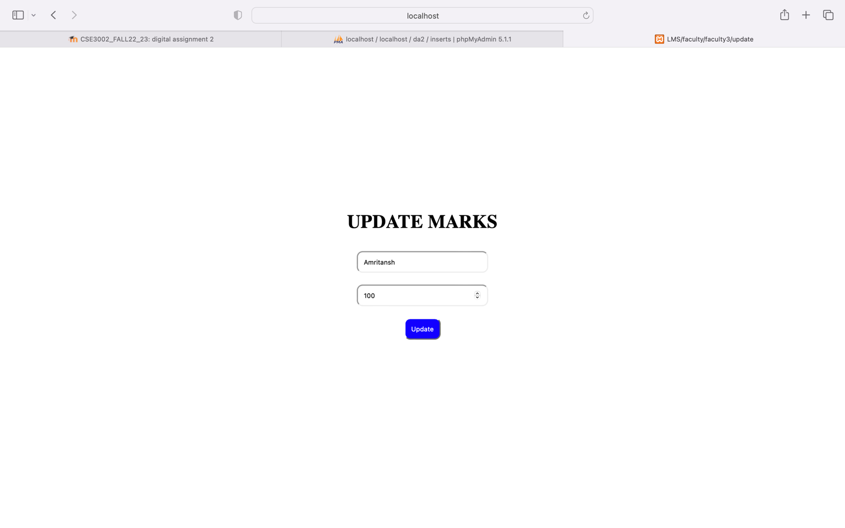

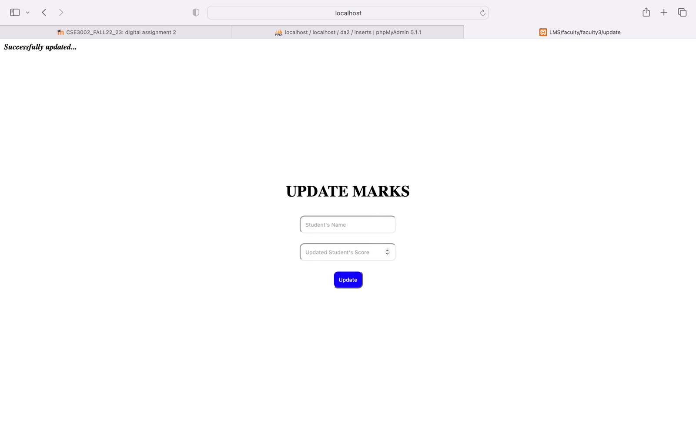

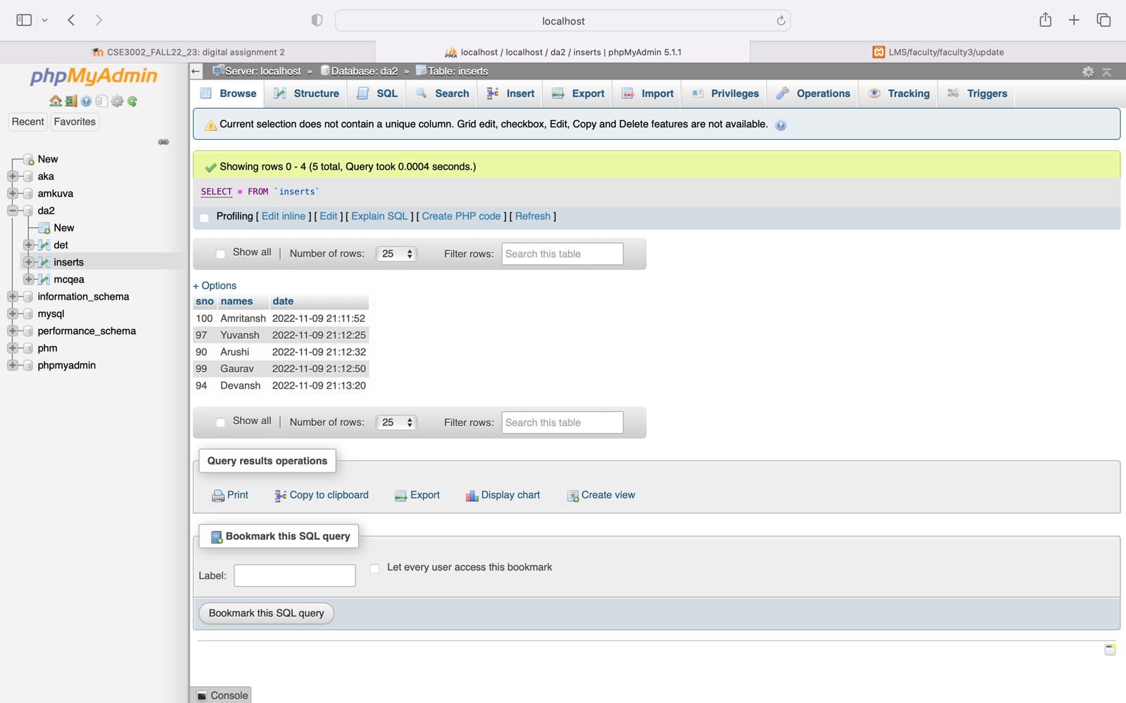

<?php

$insert = false;

if(isset($_POST['names'])){

$con = mysqli_connect("localhost", "root", "", "da2");

if(!$con){

die("connection to this database failed due to" . mysqli_connect_error());

}

$names = $_POST['names'];

$sql = "DELETE from inserts where names='$names'";

if($con->query($sql) == true){

echo "<I><B>Successfully deleted...</B></I>";

$insert = true;

}

else{

echo "ERROR: $sql <br> $con->error";

}

$con->close();

}

?>

<!DOCTYPE html>

<html lang="en">

<head>

<meta charset="UTF-8">

<meta http-equiv="X-UA-Compatible" content="IE=edge">

<meta name="viewport" content="width=device-width, initial-scale=1.0">

<title>LMS/faculty/faculty3/delete</title>

<style>

h1{

text-align: center;

}

input[type="submit"]{

margin: 10px;

padding: 10px;

border-radius: 10px;

}

input[type="text"],[type="number"]{

margin: 10px;

padding: 10px;

border-radius: 10px;

width: 200px;

}

div{

padding-top: 250px;

}

input[type="submit"]{

background-color: rgb(17, 0, 255);

color: white;

}

input[type="submit"]:hover{

background-color: rgb(0, 0, 0);

}

</style>

</head>

<body>

<div>

<h1>DELETE MARKS</h1>

<form align="center" action="delete.php" method="POST">

<input type="text" name="names" id="names" placeholder="Student's Name"><br>

<input type="submit" value="Delete">

</form>

</div>

</body>

</html>

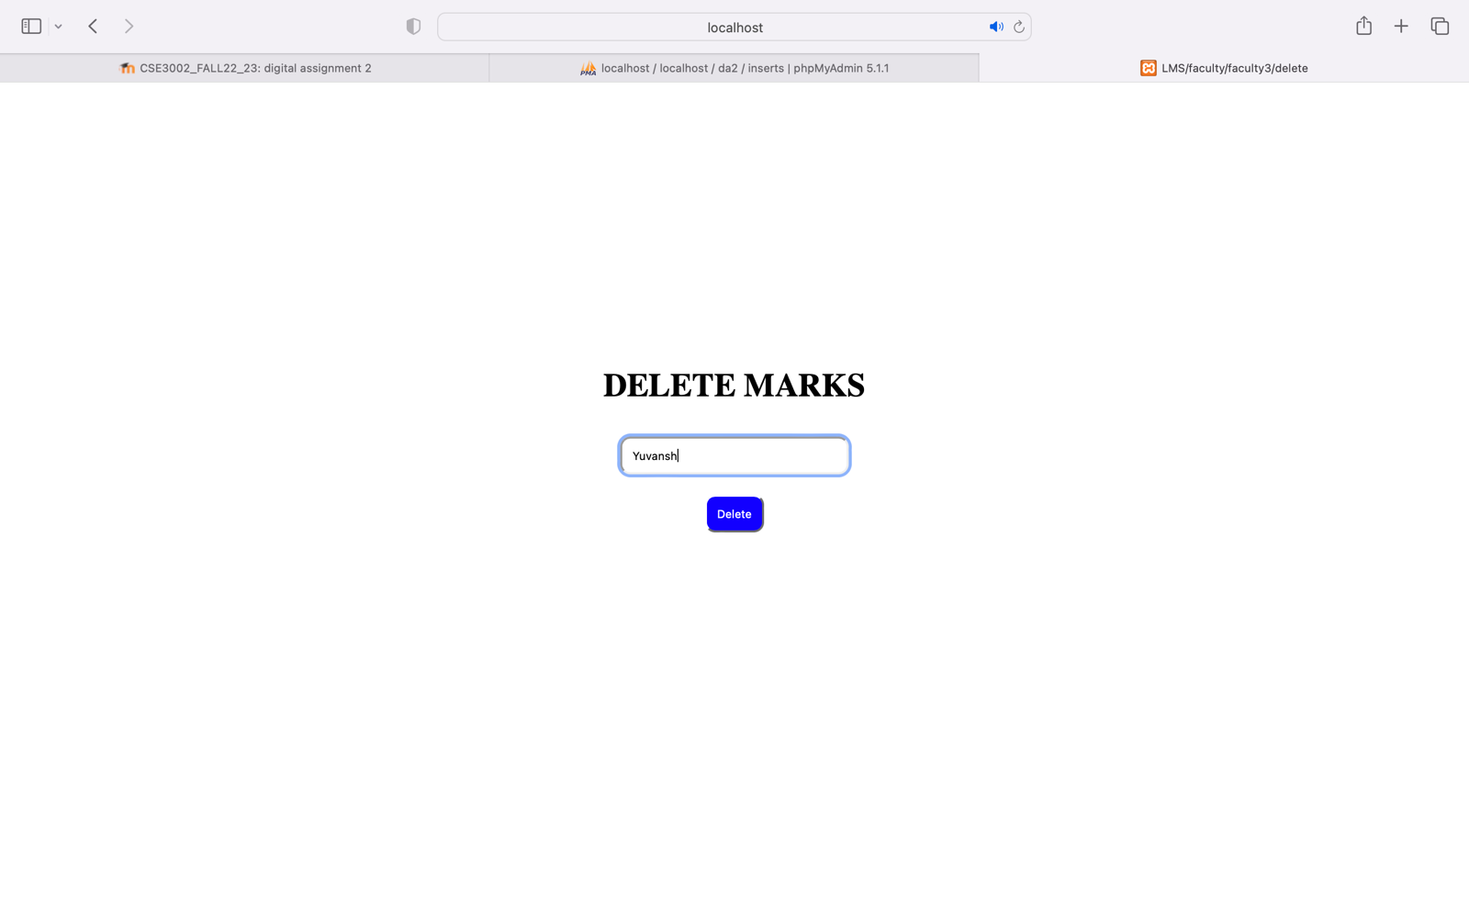

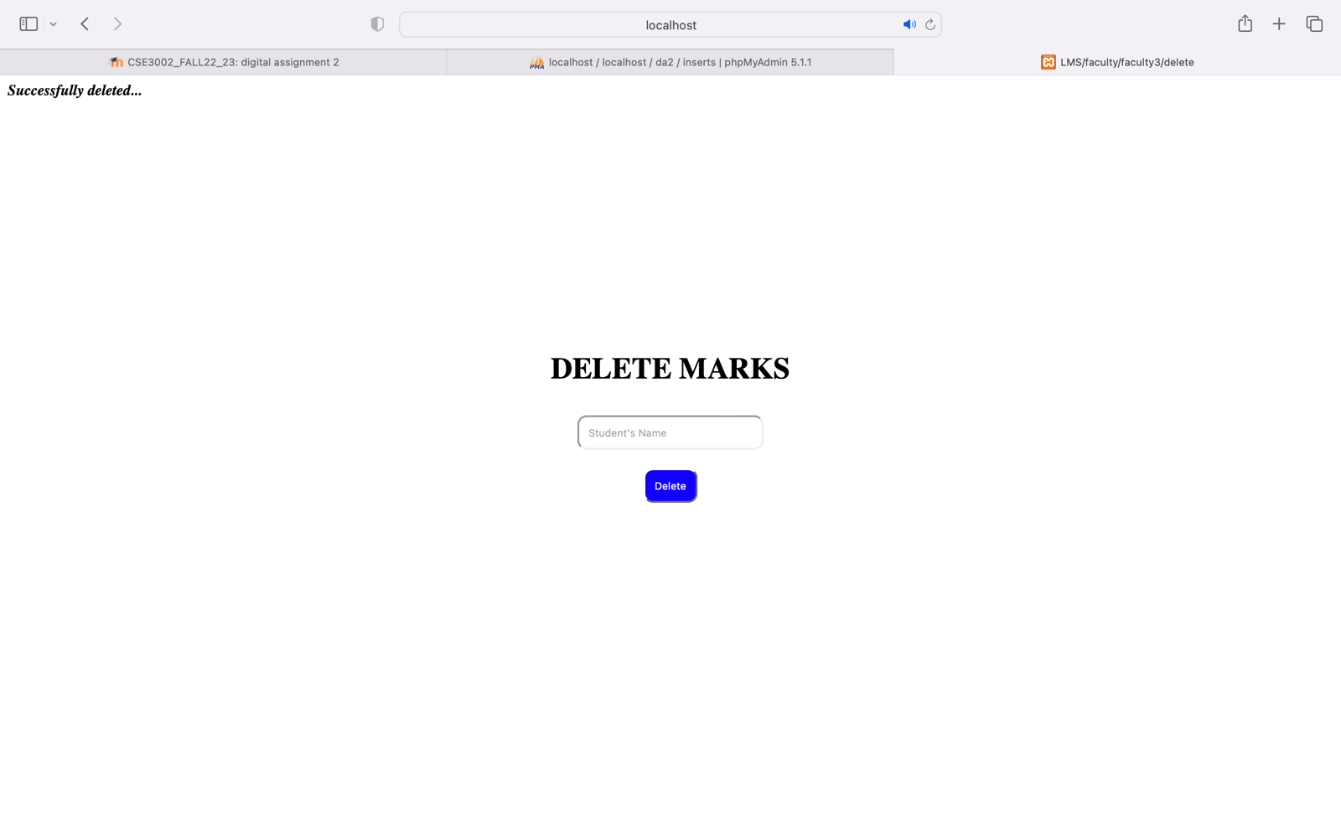

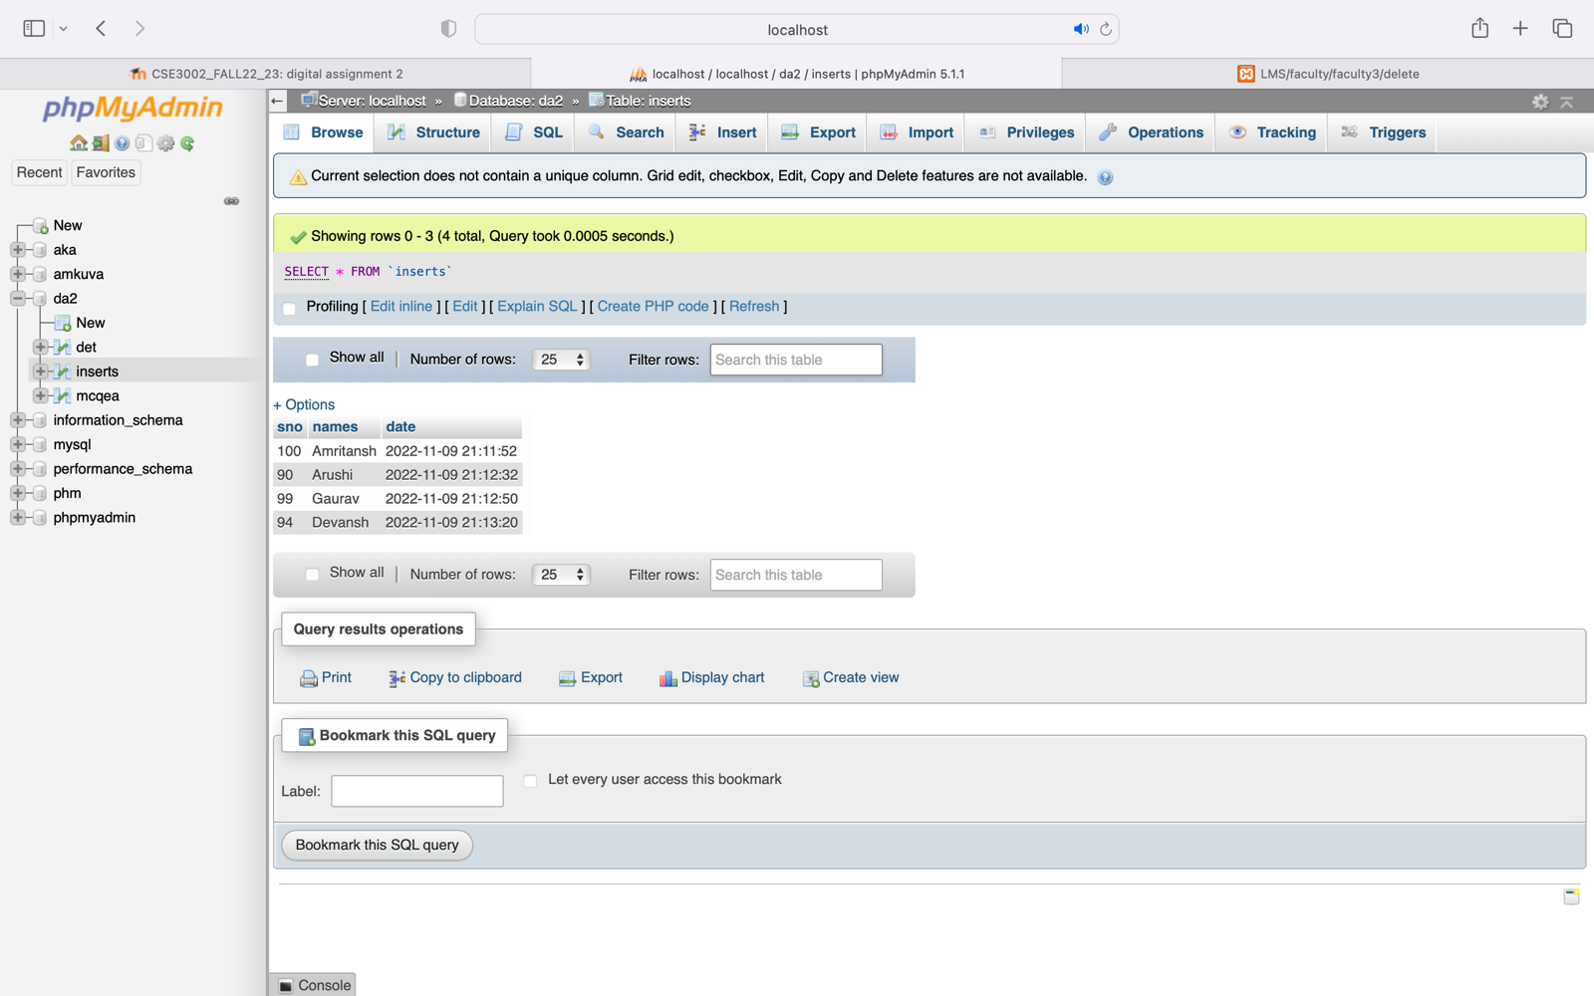

<?php

$insert = false;

if(isset($_POST['submit'])){

$conn = mysqli_connect("localhost", "root", "", "da2");

if($conn-> connect_error) {

die("connection failed:".$conn->connect_error);

}

$query = "SELECT * FROM inserts ORDER BY sno DESC;";

$result = mysqli_query($conn,$query);

if($conn->query($query) == true){

echo "<I><B>Marks in sorted order...</B></I></br><B>Topper </B>";

while($row = mysqli_fetch_array($result)){

echo "<B>Name: </B>".$row['names']." ";

echo "<B>| Mark: </B>".$row['sno'];

echo"<br>";

}

}

else{

echo "ERROR: $query <br> $conn->error";

}

$conn->close();

}

?>

<!DOCTYPE html>

<html lang="en">

<head>

<meta charset="UTF-8">

<meta http-equiv="X-UA-Compatible" content="IE=edge">

<meta name="viewport" content="width=device-width, initial-scale=1.0">

<title>LMS/faculty/faculty3/smft</title>

<style>

h1{

text-align: center;

}

input[type="submit"]{

margin: 10px;

padding: 10px;

border-radius: 10px;

}

input[type="text"],[type="number"]{

margin: 10px;

padding: 10px;

border-radius: 10px;

width: 200px;

}

div{

padding-top: 250px;

}

input[type="submit"]{

background-color: rgb(17, 0, 255);

color: white;

}

input[type="submit"]:hover{

background-color: rgb(0, 0, 0);

}

</style>

</head>

<body>

<div>

<h1>SORT MARKS & FIND TOPPER</h1>

<form align="center" action="smft.php" method="POST">

<input type="submit" name="submit" id="submit" value="GO">

</form>

</div>

</body>

</html>

